**K. J. Somaiya College of Engineering, Mumbai-77**

(Autonomous College Affiliated to University of Mumbai)

**Report on Designing optimal COVID-19 testing stations locally: A discrete event simulation model applied on a university campus**

**Team Number: 12**

**Team members with roles:**

1. Samriddhi Singhai – Prsesenter
2. Burhanuddin Plumber – Communicator
3. Krutik Rambhia – Researcher
4. Riya Rege - Editor

**Objective of paper:**

This paper aims to design a COVID-19 testing station across the university campus so that responsible people can arrange an adequate number of medicines and operators and allocate them to different workstations based on requirements and resources available. The model developed should be able to identify bottlenecks and different areas having the scope of improvement in the process to make the most out of the human resources and save time. The authors also wish that this model can be used by anyone who wants to reuse or adapt it in other contexts.

**Resource Used:**

**Type of paper:**

Implementation

**Implementation:**

With no pre-existing models to work on and just a table-based process flow authors started with knowing the process of saliva-based testing of COVID-19 and prepared process flow charts and time-based Gantt charts. This process provided the initial bottlenecks/ problems that can be addressed before making the model. A Discrete Event Simulation (DES) model was prepared in AnyLogic software. The DES model was prepared using the 20-point checklist to improve scientific soundness and reproducibility. This 20-point checklist helps to figure out all the requirements and details of simulation such as the source of data, algorithms used, implementation, logic, and experimentation.

The Gantt Charts and flow charts provided information like what are various tasks, their details, resources used, and time duration of each task. A logigram representation is used to depict the detailed process flow of testing saliva samples. This is a very essential part of generating any DES model.

DES model was created and run for different various configurations of operators and machines used for testing to find out the optimal one that can do 10000 tests in 10-12 hours of time. Model is built and deployed to optimize four main steps namely preparation, collection, pre-testing, and testing as understood from logigram.

The below given image shows a complete overview of the DES model of the Covid-19 testing process with a pool of resources and equipment.

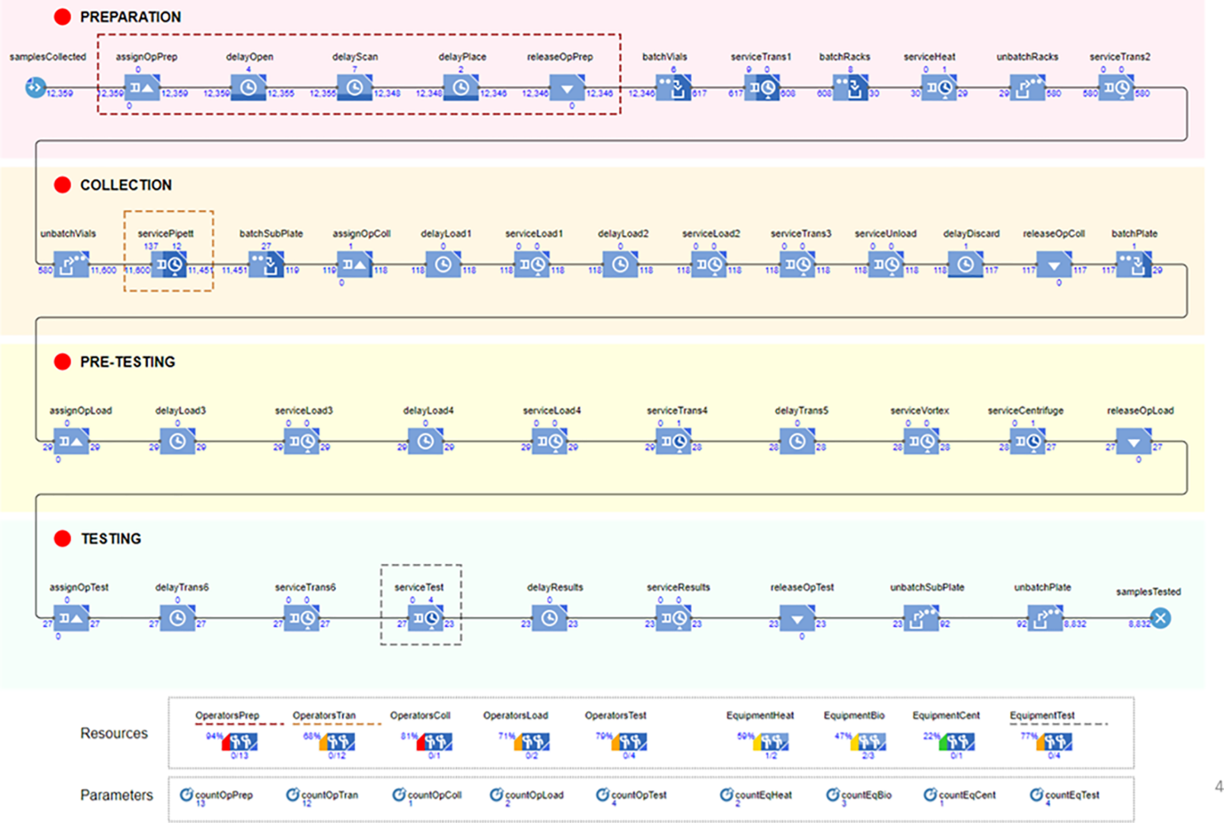

The DES model was run 10 times for each configuration in order to find an ideal configuration that optimizes the testing process and

**Results:**

DES easily detected resources that are underused i.e. are kept idle and overused i.e. high utilization percentages. Bottlenecks that were detected during the simulation were

1. Number Of Operators
2. Numbers of resources allocated to transfer operation
3. Number of machines available to test batch of 384 vials.

2 measures that had significant importance on time for testing are the number of operators and the number of machines for testing COVID-19. Changing the numbers of operators and machines, generated the following results.

|  |  |  |
| --- | --- | --- |
| Simulation Number | No. of operators and Machines | Output |
| 1 | Insufficient | 13.5 hr of mean testing time |
| 2 | Adding 1 machine | 12.5 hr of mean testing time |
| 3 | Machines > 4 | No significant change |
| 4-6 | Adding operators in each simulation | Reducing the queue significantly |
| 7 | 13 operators and 4 machines | 10.5 hr of mean testing time |
| 8-10 | Increasing machines and operators simultaneously in each simulation | No signigicant change. |

**Inferences:** Your inference from the paper studied

**References**:

[1] Saidani, M., Kim, H., & Kim, J. (2021). Designing optimal COVID-19 testing stations locally: A discrete event simulation model applied on a university campus. *PloS one*, *16*(6), e0253869.